

**Title:** Gift Aid Interface Link (GAIL) – Technical Guidance

Introduction

In April 2013, HMRC introduced a new system for claiming Gift Aid repayments. This new system, named Charities Online, is due to fully replace the old R68(i) process by 30th September 2013.

For many of the larger charities, there will be a need to submit Gift Aid repayment data by directly linking up with Charities Online. The tool that we have created, the Gift Aid Interface Link (GAIL), will enable charities to do this.

This pack needs to be read in conjunction with the guidance provided by HMRC on the Gift Aid claim process.

What is GAIL?

GAIL is a Windows class library which provides a set of methods for:

* Creating Government Gateway submission files
* Submitting files to the Government Gateway
* Reading and responding to messages from the Government Gateway.

It consists of:

* HMRC service classes – a representation of the government XML schema in object oriented form
* Two classes which create and read files
* A dispatcher class which handles sending files
* A controller class which allows you to control the above

Environment needed to run it:

* Windows
* Any version that has .Net framework 4.0 or higher installed

To use the tool you would normally call controller methods to undertake whatever action you want to perform. So, for example, the simplest thing would be to create a submission file from a data set.

How to Integrate the Tool

**Step 1 – Create an application**

Firstly, you need to create, or decide on, which application you want to use to refer to the GAIL library.

Here are some examples:



*Charities Online is a specific part of the larger Government Gateway that deals with Gift Aid* submissions.

**Step 2 – Provide data table**

Provide a standard ADO.net data table which acts as the input for GAIL. The input table has no limits to the number of rows it can have, however the tool may split the table into smaller ones if it exceeds the Charities Online limit.

There are different required fields depending on the data that you are submitting. The data will fall into one of these categories:

* Donations with individual donor details – Fields required are:

|  |  |  |
| --- | --- | --- |
| **Name of Field** | **Description** | **Mandatory?** |
| Title | Title of donor | No |
| Fore | First name of donor | Yes |
| Sur | Last name of donor | Yes |
| House | House name/number or first line of address | Yes |
| Postcode | Postcode of donor address | Yes, for UK addresses |
| Sponsored | Indicates if donations came from a sponsorship. See HMRC documentation for more details. The value can be Y or Yes. |  |
| Date | Donation date | Yes |
| Total | Amount of the donation | Yes |

* Donations with aggregated details:

|  |  |  |
| --- | --- | --- |
| **Name of Field** | **Description** | **Mandatory?** |
| Description | A meaningful description of the donations | Yes |
| Date | Donation date | Yes |
| Total | Amount of the donation | Yes |

**In the input table, the column names must match the names of the fields above exactly.**

You can include more columns than this if you want, but these are the required ones.

If you want to include aggregated donations in your submission, you must include a column called **Type** and for each row that is an aggregated donation, the value of **Type** must be **AGG**. The rows for individual donations must have a type of **GAD**. If you don’t have a type column the application will treat everything as an individual donor.

You can include other income if you set the type value for the relevant rows to **OtherInc**.

The required fields are:

|  |  |  |
| --- | --- | --- |
| **Name of Field** | **Description** | **Mandatory?** |
| Payer | Full name of the other income payer | Yes |
| OIDate | The date of payment | Yes |
| Gross | The gross payment received | Yes |
| Tax | The tax deducted | Yes |

See the included example .csv file.

**Step 3 – Decide on action**

Possible actions you can do with the tool are:

* Initiate the whole gift aid process
* Create a straightforward xml file out of your data table
* Send a data request to the Government Gateway
* Send a polling message to the Government Gateway (to check on claim progress)
* Create own gift aid process using the individual steps that are available in the tool and required by the Government Gateway. This is the process as provided by HMRC:

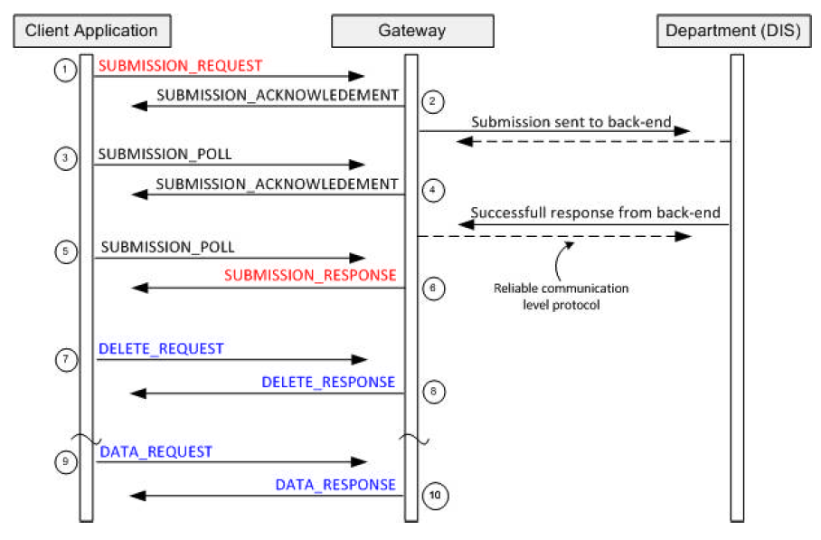

The GAIL tool provides the core of the ‘Client Application’ step (although it doesn’t provide the whole of the ‘client application’ – it needs to be called by some other harnessing code).

**Step 4 – Log file**

The logging is implemented using [log4net](http://logging.apache.org/log4net/) so all the configuration that is available there is available to you. The default logging level is set to INFO. You can change this according to your development and deployment needs.

You need to initialize log4net in the calling application. An easy way is by declaring the attribute [assembly: log4net.Config.XmlConfigurator(Watch = true)] for the calling class, or alternatively create some other log4net set up method.

Once that is done, a verbose narrative of events is written to a log file, so you need to decide what to do with the logs. You could:

* Leave them as straightforward text files (e.g. on disk)
* Put them in a database table
* Display on a web page

**Step 5 – Configuration**

You will need to configure the tool so that it:

1. Does what you require technically
2. Contains information about the charity you are submitting Gift Aid claims on behalf of (e.g. the charity’s name and charity number)

GAIL also requires access to a writable location (e.g. C://temp).

|  |  |  |  |
| --- | --- | --- | --- |
| **Key Field** | **Value Field** | **Explanation** | **Possible Values** |
| key="env" | value="local"/> | Environment. It could be your local system, the development Government Gateway or the live Government Gateway. | Local  Test  Live |
| key="PasswordMethod" | value="clear"/> | When you store a password in a file you can store it so it’s visible or you can hash it so it’s obscured. MD5 hashes the password. | Clear  MD5 |
| key="BatchSize" | value="2500"/> | Maximum number of donation records in a file. Larger files will be split automatically by the tool. | Any whole number |
| key="ReasonableWaitInMinutes" | value="10"/> | Length of time that GAIL will poll the Government Gateway for before it gives up. | Any whole number |
| key="RestartAfterInMinutes" | value="60"/> | If there is no response within the ReasonableWaitInMinutes, this is how long it will be until it starts trying again. | Any whole number |
| key=”SubmissionRequestFilePrefix” | value=”LocalRequestMessage”/> | Choosing the start of the file name for your submission file. | Text |
| key=”SubmissionPollFilePrefix” | value=”LocalPollMessage”/> | Choosing the start of the file name for your poll message. | Text |
| key="SendURILocal" | value="<http://localhost:5665/LTS/LTSPostServlet>"/> | If running the local test service, the address to send to needs to go here. | URL |
| key="SendURIDev" | value="<https://secure.dev.gateway.gov.uk/submission>"/> | If using Government Gateway development service, the address to send to needs to go here. | URL |
| key="SendURILive" | value="<https://secure.gateway.gov.uk/submission>"/> | If using Government Gateway live service, the address to send to needs to go here. | URL |
| key="PollURIDev" | value="<https://secure.dev.gateway.gov.uk/poll>"/> | The address to poll to if using the development Government Gateway. | URL |
| key="PollURILive" | value="<https://secure.gateway.gov.uk/poll>"/> | The address to poll to if using the live Government Gateway | URL |
| key="ChannelVersion" | value="2.0"/> | Version number of the software product used for submission | Decimal number |
| key="ChannelProduct" | value="GAIL"/> | Name of the software product being used for submission | Text |
| key="ChannelURI" | value="1234"/> | Vendor’s reference number (this is provided by HMRC to registered charities) | Number |
| key="GovTalkDetailsKeyType" | value="CHARID"/> | Shows the type of Government Gateway submission this is. Provided by HMRC. See <http://www.hmrc.gov.uk/softwaredevelopers/charities-online-valids.pdf> | Text |
| key="GovTalkDetailsKey" | value="AB12345"/> | Your charity ID. Provided by HMRC. | Text |
| key="GovTalkDetailsTargetOrganistion" | value="HMRC"/> | Specifies that this is a HMRC submission. | Text |
| key="SenderID" | value="1234567890"/> | Reference number of the individual who is registered with HMRC to make the submission. Provided by HMRC. It is also known as User ID. | Any whole number |
| key="SenderAuthenticationMethod" | value="clear"/> | Possible values are ‘clear’ (password is in clear text) or ‘MD5’ (password is MD% hashed) | Text |
| key="SenderAuthenticationRole" | value="principal"/> | See <http://www.hmrc.gov.uk/softwaredevelopers/charities-online-valids.pdf> | Text |
| key="SenderAuthenticationValue" | value="testing1"/> | Sender’s password | Text |
| key="MessageDetailsClass" | value="HMRC-CHAR-CLM"/> | Provided by HMRC  See <http://www.hmrc.gov.uk/softwaredevelopers/charities-online-valids.pdf> | Text |
| key="MessageDetailsQualifier" | value="request"/> | Identifies what kind of message this is | Text |
| key="MessageDetailsFunction" | value="submit"/> | Identifies what the message does | Text |
| key="MessageDetailsTransformation" | value="XML"/> | Defines what kind of file this is - XML, HTML or Plain Text. | XML  HTML  Text |
| key="MessageDetailsGatewayTest" | value="1"/> | Used for a Government Gateway test.  Should be absent or set to 0 for submissions to the live Gateway.  Should be present and set to 1 for submissions to the Gateway Reflector Service. | 0  1 |
| key="GovTalkMessageEnvelopeVersion" | value="2.0"/> | Refers to the version number for the XML schema. Provided by HMRC. See <http://www.hmrc.gov.uk/softwaredevelopers/charities-online-valids.pdf> | Decimal number |
| key="IRheaderKey" | value="AB12345"/> | Charity ID. Same as GovTalkDetailsKey. See <http://www.hmrc.gov.uk/softwaredevelopers/charities-online-valids.pdf> | Text |
| key="IRheaderPeriodEnd" | value="2013-10-31"/> | The period end in the format yyyy-mm-dd.  See <http://www.hmrc.gov.uk/softwaredevelopers/charities-online-valids.pdf> | Date |
| key="IRheaderDefaultCurrency" | value="GBP"/> | Default currency. This is currently restricted to only allow GBP. | Text |
| key="IRheaderSender" | value="Company"/> | Who the claim is sent on behalf of. Must be either **Individual, Company, Agent, Bureau, Partnership, Trust, Employer, Government, Acting in Capacity** or **Other** to identify the type of submitter. | Text |
| key="R68AuthOfficialForeName" | value="Joe"/> | First name of authorised person | Text |
| key="R68AuthOfficialSurname" | value="Bloggs"/> | Surname of authorised person | Text |
| key="R68AuthOfficialPostcode" | value="AB1 1AA"/> | Postcode of authorised person | Text |
| key="R68AuthOfficialPhone" | value="020 123 4312"/> | Phone number of authorised person | Numerical |
| key="R68Declaration" | value="yes"/> | A statement declaring that you agree to the terms and conditions. Refer to HMRC documentation. | Yes |
| key="R68ClaimOrgName" | value="A Great Charity"/> | Name of the charity who is submitting the claim | Text |
| key="R68ClaimHMRCRef" | value="AB12345"/> | Charity ID. Same as GovTalkDetailsKey. |  |
| key="R68RegulatorName" | value="CCEW"/> | Name of the regulator. These can be:  CCEW – Charity Commission for England and Wales  CCNI – Charity Commission for Northern Ireland  OSCR – Office of the Scottish Charity Regulator | CCEW  CCNI  OSCR |
| key="R68RegulatorNumber" | value="123456"/> | Regulator’s number e.g. your charity number | Text |
| key=”R68ClaimAdjustmentSpecified” | value=”true”/> | Do you want to include claim adjustment values? | True  False |
| key=”R68ClaimAdjustmentAmount” | value=”50.00”/> | The amount of the claim adjustment | Decimal number |
| key="GASDSConnectedCharities" | value="no"/> | Relevant if you are part of Gift Aid Small Donations Scheme. Read more in HMRC documentation. |  |
| key="GASDSCommBldgs" | value="no"/> | Relevant if you are part of Gift Aid Small Donations Scheme. Read more in HMRC documentation. |  |